ESP32-CAM uses the Arduino IDE for video streaming and photography

目录
ESP32-CAM使用Arduino IDE进行视频流和拍照 1
一、Arduino开发环境搭建 2
二、ESP-CAM视频流和拍照示例 7

Arduino development environment
Download Arduino IDE from the Arduino website

(2) click I agree, click Next
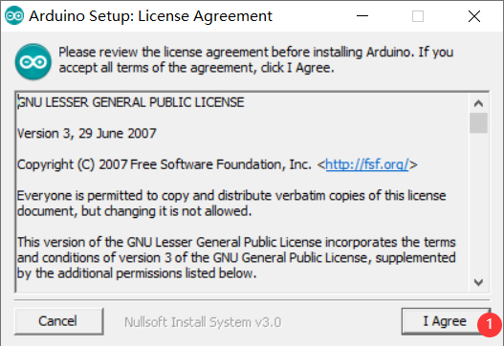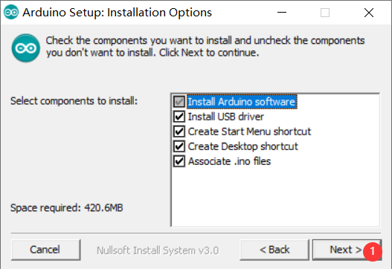

(3) install on C drive by default, you can click Browse to change the installation location
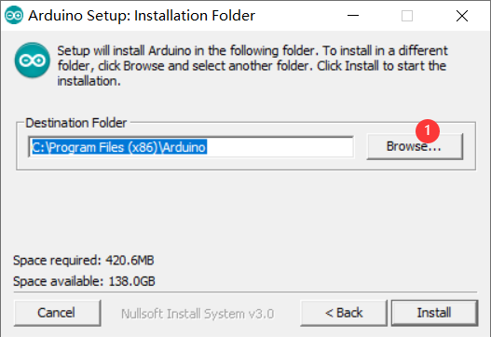

(4) here I installed it on disk D under the Arduino folder (remember the installation path)
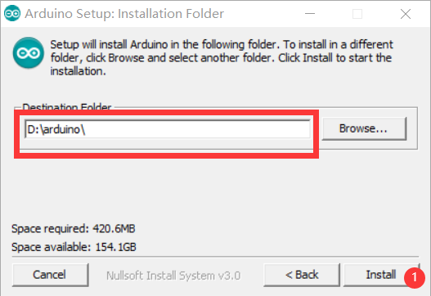

(5) wait for the installation to complete, then open hardware in the installation path
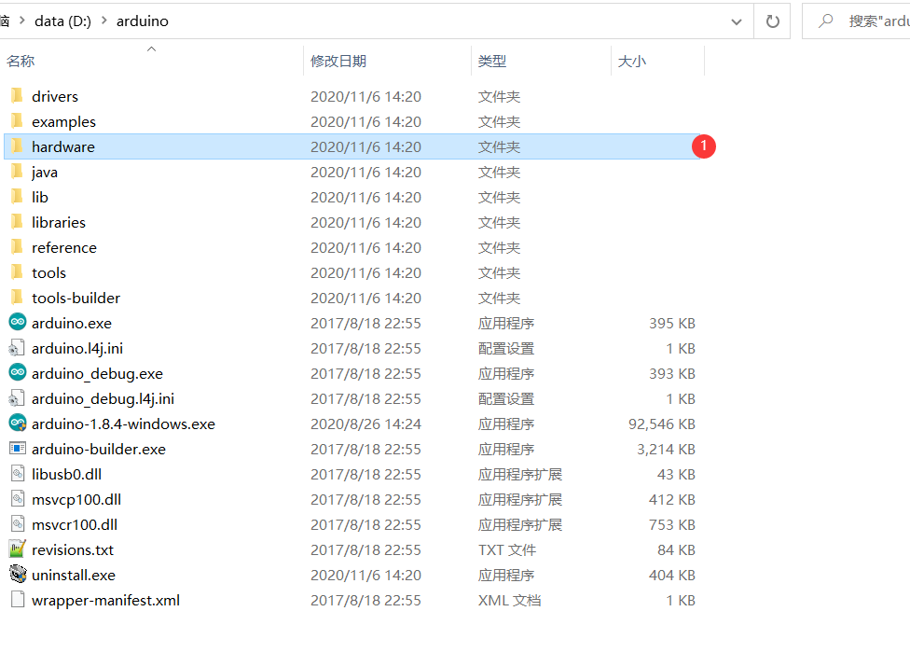

(6) download the SDK: https://pan.baidu.com/s/1bxt0buubzcrgqt9fab5qxw (extract code: 8ita) and Unzip it to the hardware directory
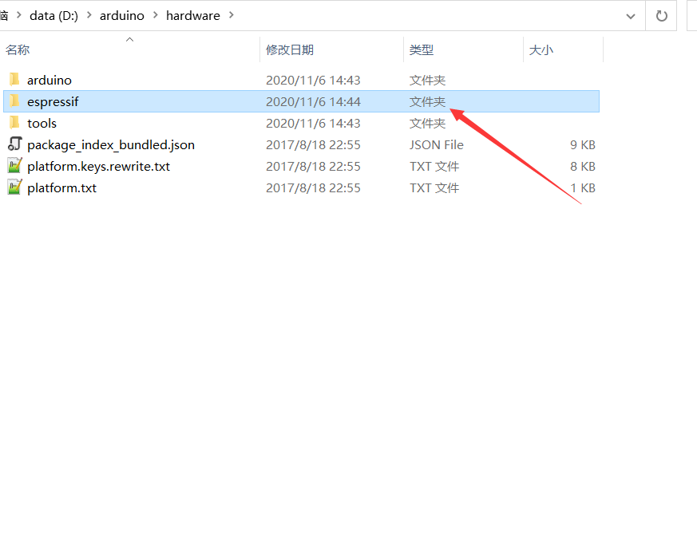
(7) open the Arduinoide and select the corresponding development board
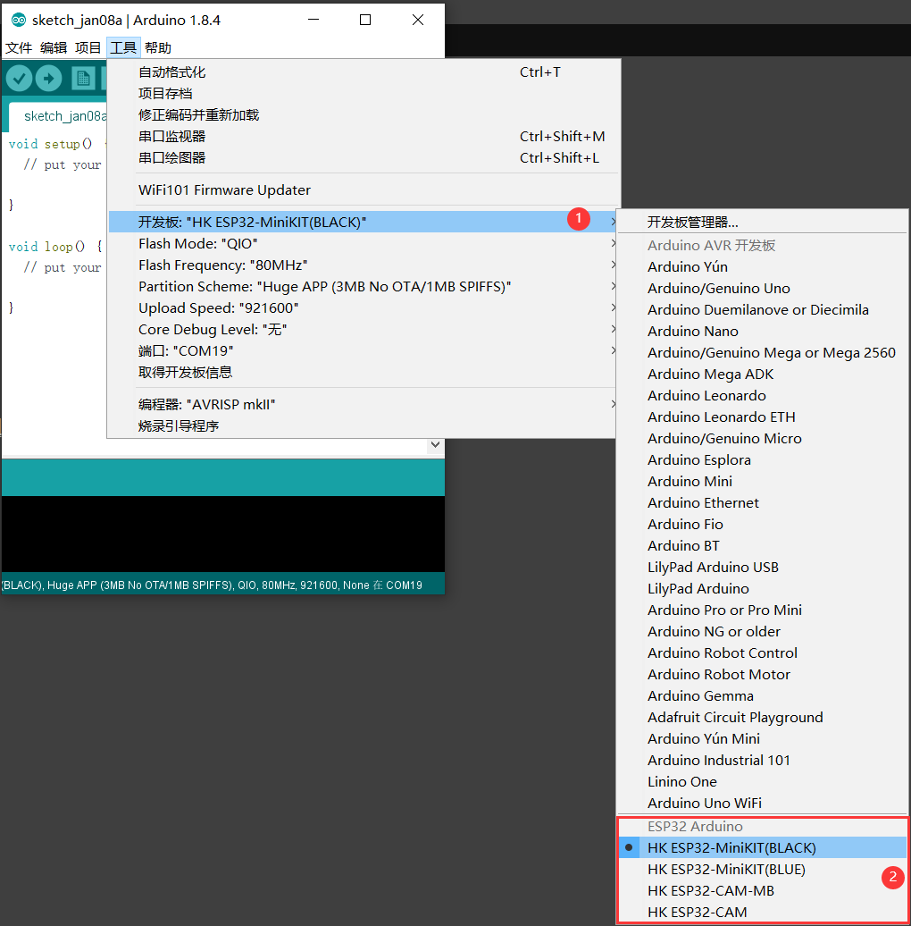
Now that the Arduino IDE development platform is set up, here's how to use the example

Esp-cam video stream and photography examples
(1) download Camera sample: https://pan.baidu.com/s/1vsrq1r4uufc9fujguihqwg (extract code: 7CLD)
(2) once the download is complete, go to the“Camera” directory and double-click to open“Camera. Ino”
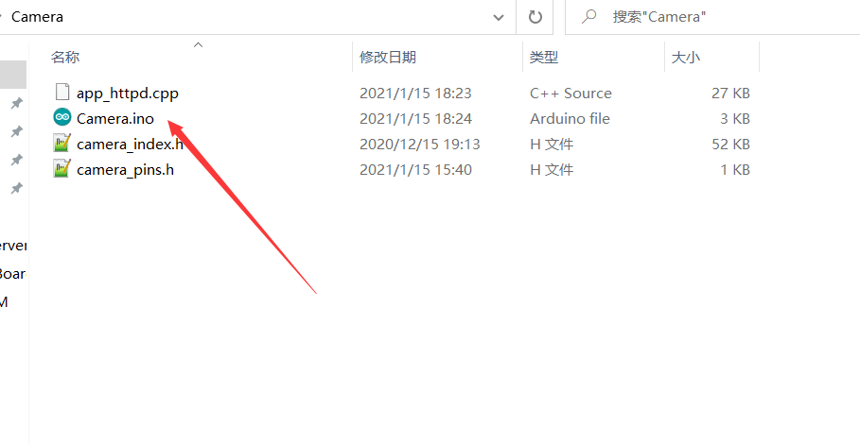
(3) select the Development Board, select the port, upload the code
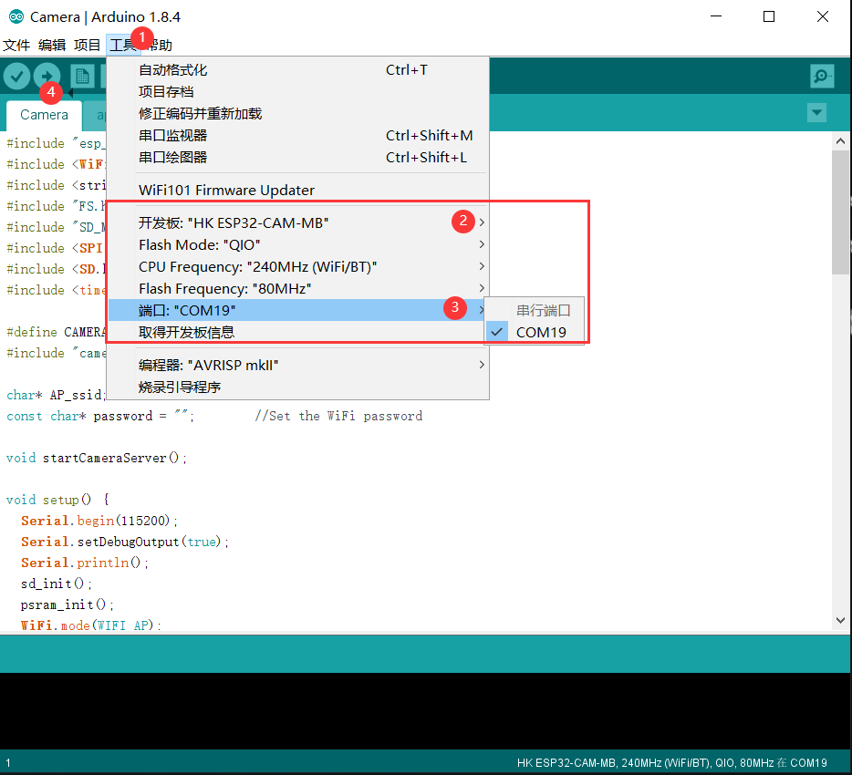
(4) * * open the serial port, select the baud rate 115200, reset the development board, view the serial port output * *
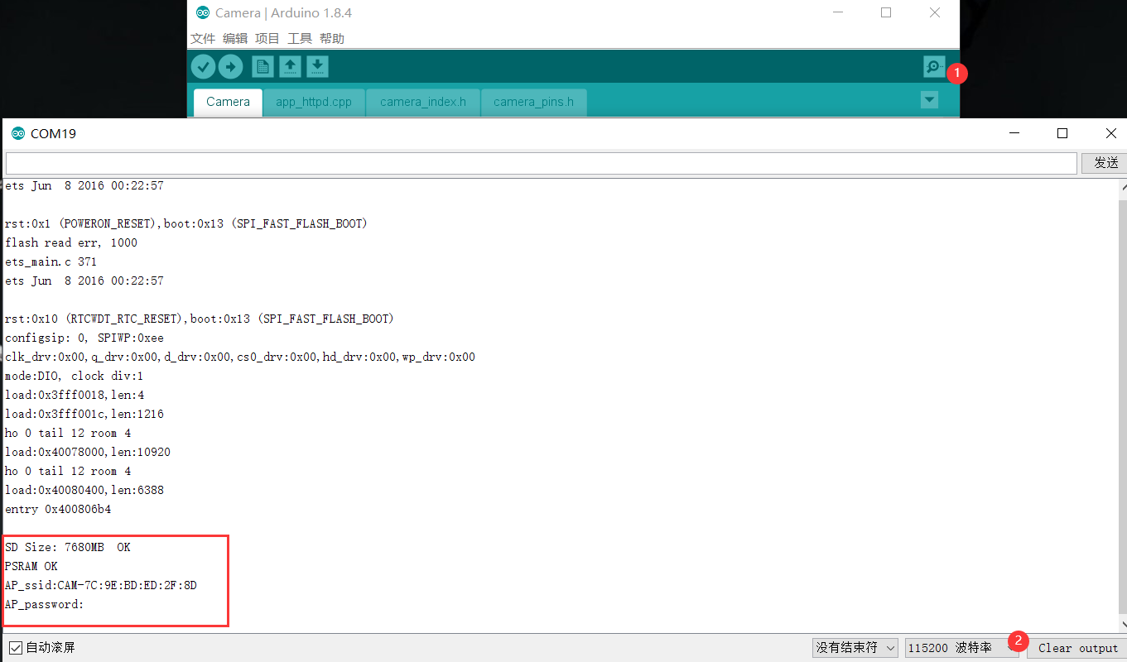

(5) access the video streaming server
You can turn on your phone's wi-fi and use it to connect to“ESP32-CAM”(each board has a different suffix) . Open a browser and Type 192.168.4.1. Press the Start Streaming button to Start the video stream. Click Get Still to take a picture. The picture is stored on an SD card. The name of the picture is random
